***Solution Section* 4.2 – Calculus with Parametric Curves**

***Exercise***

Find all the points at which the curve has the given slope. 

***Solution***

 





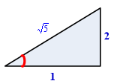



***Exercise***

Find all the points at which the curve has the given slope. 

***Solution***

 



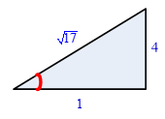





***Exercise***

Find all the points at which the curve has the given slope. 

***Solution***

 



 ∴ There are ***no*** points on this curve with slope 1.

***Exercise***

Find all the points at which the curve has the given slope. 

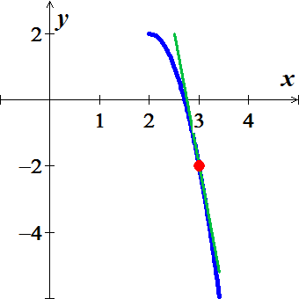***Solution***

 







***Exercise***

Find an equation of the line tangent to the curve at the point corresponding to the given value of *t*.



***Solution***

 





At 



The equation of the tangent line is





***Exercise***

Find an equation of the line tangent to the curve at the point corresponding to the given value of *t*.



***Solution***

 



At 



The equation of the tangent line is





***Exercise***

Find an equation of the line tangent to the curve at the point corresponding to the given value of *t*.



***Solution***

 



At 



The equation of the tangent line is



***Exercise***

Find an equation of the line tangent to the curve at the point corresponding to the given value of *t*.



***Solution***

 





At 



The equation of the tangent line is

 



***Exercise***

Find an equation of the line tangent to the curve at the point corresponding to the given value of *t*.



***Solution***

 



At :



The equation of the tangent line is

 



***Exercise***

Find an equation of the line tangent to the curve at the point corresponding to the given value of *t*.



***Solution***

 



At :



The equation of the tangent line is

 



***Exercise***

Find an equation of the line tangent to the curve at the point corresponding to the given value of *t*.



***Solution***

 



At 



The equation of the tangent line is

 

***Exercise***

Find an equation of the line tangent to the curve at the point corresponding to the given value of *t*.



***Solution***

 





At :



The equation of the tangent line is

 



***Exercise***

Find the tangent to the curve at the point defined by the given value of *t*. Also find the value of  at this point 

***Solution***













The point 





 









The tangent to the curve at the point  is:

 







 







***Exercise***

Find the tangent to the curve at the point defined by the given value of *t*. Also find the value of  at this point 

***Solution***





***The point*** 





 





The tangent to the curve at the point  is:

 





 





***Exercise***

Find the tangent to the curve at the point defined by the given value of *t*. Also find the value of  at this point 

***Solution***







***The point*** 





 







The tangent is:

 







 







***Exercise***

Find the tangent to the curve at the point defined by the given value of *t*. Also find the value of  at this point 

***Solution***





***The point*** 





 







The tangent is:

 











 











***Exercise***

Find the tangent to the curve at the point defined by the given value of *t*. Also find the value of  at this point 

***Solution***





***The point*** 







 







The tangent is:

 









 







***Exercise***

Find the tangent to the curve at the point defined by the given value of *t*. Also find the value of  at this point 

***Solution***





***The point*** 





 





The tangent is:













 







***Exercise***

Find the tangent to the curve at the point defined by the given value of *t*. Also find the value of  at this point 

***Solution***





 





The tangent to the curve at the point 

 





 

***Exercise***

Find the tangent to the curve at the point defined by the given value of *t*. Also find the value of  at this point 

***Solution***





 





The tangent to the curve at the point 

 







 



***Exercise***

Find the tangent to the curve at the point defined by the given value of *t*. Also find the value of  at this point 

***Solution***





 





The tangent to the curve at the point 

 





 

***Exercise***

Find the tangent to the curve at the point defined by the given value of *t*. Also find the value of  at this point 

***Solution***





 





The tangent to the curve at the point 

 







 





***Exercise***

Find the tangent to the curve at the point defined by the given value of *t*. Also find the value of  at this point 

***Solution***





 







The tangent to the curve at the point :

 







 





***Exercise***

Find the tangent to the curve at the point defined by the given value of *t*. Also find the value of  at this point 

***Solution***





 







The tangent to the curve at the point : 





 





***Exercise***

Find the tangent to the curve at the point defined by the given value of *t*. Also find the value of  at this point 

***Solution***





 







The tangent to the curve at the point :

 







 





***Exercise***

Find the tangent to the curve at the point defined by the given value of *t*. Also find the value of  at this point 

***Solution***





 





The tangent to the curve at the point 

 



 





 





***Exercise***

Find the tangent to the curve at the point defined by the given value of *t*. Also find the value of  at this point 

***Solution***





 







The tangent to the curve at the point :

 







 





***Exercise***

Find the tangent to the curve at the point defined by the given value of *t*. Also find the value of  at this point 

***Solution***





 





The tangent to the curve at the point :

 









 





***Exercise***

Find the equations of the tangent lines at the point where the curve crosses itself



***Solution***









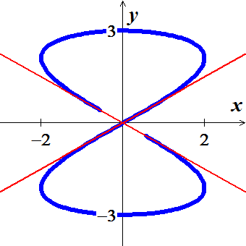



The point at  is 

The tangent line: 



The point at  is 

The tangent line: 

***Exercise***

Find the equations of the tangent lines at the point where the curve crosses itself



***Solution***

The graph crosses itself at the point 







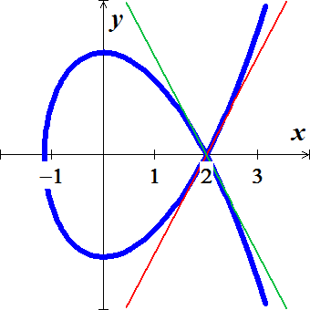







The tangent line: 





The tangent line: 



***Exercise***

Find the equations of the tangent lines at the point where the curve crosses itself



***Solution***

The graph crosses itself at the point 

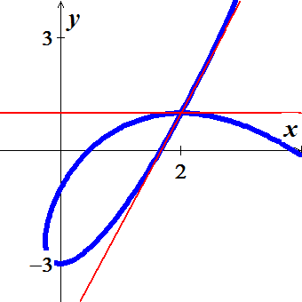













The tangent line: 



The tangent line: 



***Exercise***

Find the equations of the tangent lines at the point where the curve crosses itself



***Solution***

The graph crosses itself at the point 

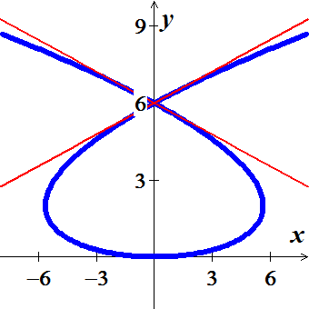













The tangent line: 







The tangent line: 

***Exercise***

Find the slope of the curve  at the given value of *t*. Define *x* and *y* as differentiable functions. 

***Solution***



























 







***Exercise***

Find the slope of the curve  at the given value of *t*. Define *x* and *y* as differentiable functions. 

***Solution***































 





***Exercise***

Find the slope of the curve  at the given value of *t*. Define *x* and *y* as differentiable functions. 

***Solution***





















 





***Exercise***

Find  for 

***Solution***





 

 



 



***Exercise***

Find  for 

***Solution***





 











 





***Exercise***

Find  for 

***Solution***





 







 

***Exercise***

Find  for 

***Solution***





 







 



***Exercise***

Find an equation of the line tangent to cycloid  at the points corresponding to  and .

***Solution***





 

@ 

























@ 























***Exercise***

Consider Lissajous curve, estimate the coordinates of the points on the curve at which there is



1. A horizontal tangent line
2. A vertical tangent line.

***Solution***

1.  











1. Vertical tangent line: 















***Exercise***

Consider Lissajous curve, estimate the coordinates of the points on the curve at which there is



1. A horizontal tangent line
2. A vertical tangent line.

***Solution***

1.  

















1. Vertical tangent line: 









***Exercise***

Find the area of the region 

***Solution***



 

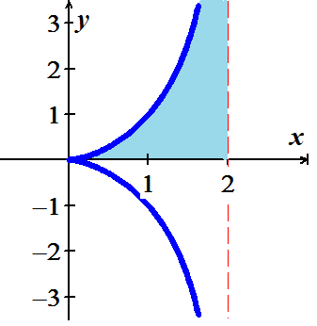 













***Exercise***

Find the area of the region 

***Solution***

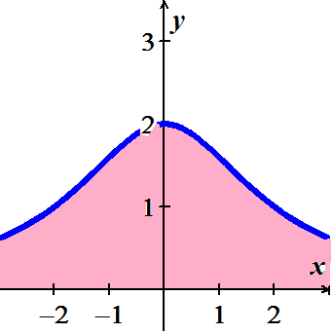

 







***Exercise***

Find the area under one arch of the cycloid 

***Solution***



 















***Exercise***

Find the area enclosed by the *y*−axis and the curve 

***Solution***









|  |  |  |
| --- | --- | --- |
|  |  |  |
| **+** |  |  |
| **−** |  |  |
| **+** |  |  |

















***Exercise***

Find the area enclosed by the ellipse 

***Solution***





















***Exercise***

Find the area of the closed curve 

***Solution***

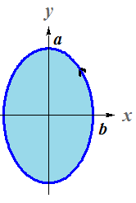

















***Exercise***

Find the area of the closed curve 

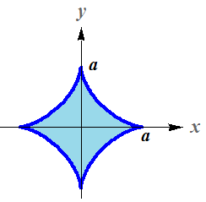***Solution***





















***Exercise***

Find the area of the closed curve 

***Solution***

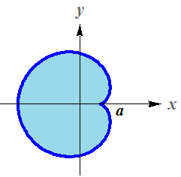







 











***Exercise***

Find the area of the closed curve 

***Solution***

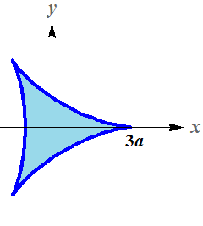







 









***Exercise***

Find the area of the closed curve 

***Solution***





 

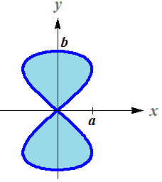 









***Exercise***

Find the area of the closed curve 

***Solution***

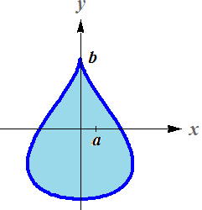





 









***Exercise***

Find the lengths of the curves 

***Solution***





















 











 









***Exercise***

Find the lengths of the curves 

***Solution***









 











***Exercise***

Find the lengths of the curves 

***Solution***













 



 







***Exercise***

Find the lengths of the curves 

***Solution***









































***Exercise***

Find the arc length of the Hypocycloid perimeter curve: 

***Solution***



 







***Exercise***

Find the arc length of the circle circumference: 

***Solution***











 









***Exercise***

Find the arc length of the Cycloid arch: 

***Solution***









 













***Exercise***

Find the arc length of the involute of a circle: 

***Solution***









 





***Exercise***

Find the arc length of 

***Solution***









 











***Exercise***

Find the arc length of 

***Solution***











 







***Exercise***

Find the area of the surface generated by revolving the curve about each given axis.



***Solution***





 









***Exercise***

Find the areas of the surfaces generated by revolving the curves



***Solution***



























***Exercise***

Find the areas of the surfaces generated by revolving the curves



***Solution***





























***Exercise***

Find the areas of the surfaces generated by revolving the curves 

***Solution***







 





***Exercise***

Find the areas of the surfaces generated by revolving the curves 

***Solution***





 





***Exercise***

Find the areas of the surfaces generated by revolving the curves 

***Solution***







 





***Exercise***

Find the areas of the surfaces generated by revolving the curves 

***Solution***







 





***Exercise***

Find the area of the surface generated by revolving the curve about each given axis.



***Solution***









 





***Exercise***

Find the area of the surface generated by revolving the curve about each given axis.



***Solution***







 







***Exercise***

Find the area of the surface generated by revolving the curve about each given axis.



|  |  |
| --- | --- |
|  |  |

***Solution***





1.  









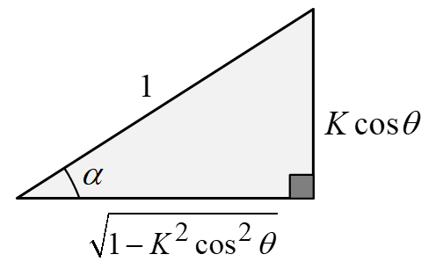 















 

1.  







































***Exercise***

Find the area of the surface generated by revolving the curve about each given axis.



|  |  |
| --- | --- |
|  |  |

***Solution***



1.  





1.  





***Exercise***

Find the area of the surface generated by revolving the curve about each given axis.



|  |  |
| --- | --- |
|  |  |

***Solution***



1.  





1.  

 



***Exercise***

Use the parametric equations  to

1. Graph the curve on the interval .
2. Find  and 
3. Find the equation of the tangent line at the point 
4. Find the length of the curve
5. Find the surface area generated by revolving the curve about the 

***Solution***

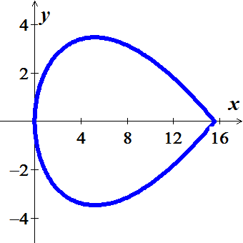

1.  





 



1. 













1. 

 











1.  









***Exercise***

Use the parametric equations 

1. Find  and 
2. Find the equation of the tangent line at the point where 
3. Find all points (if any) of horizontal tangency.
4. Determine where the curve is concave upward or concave downward.
5. Find the length of one arc of the curve

***Solution***

1. 

 









 



1. At  







Tangent Line:

 



1. 







Points of horizontal tangency: 

1. Concave downward on all open *θ*−intervals



1. 







 













***Exercise***

The involute of a circle is described by the endpoint *P* of a string that is held taut as it is unwound from a spool that does not turn.

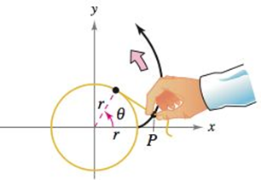

Show that a parametric representation of the involute is



***Solution***

















***Exercise***

The figure shows a piece of string tied to a circle with a radius of one unit. The string is just long enough to reach the opposite side if the circle.



Find the area that is covered when the string is unwounded counterclockwise.

***Solution***

From previous exercise, we have



At , the string is fully extended and has length *x*.

The area of region ***A*** is:

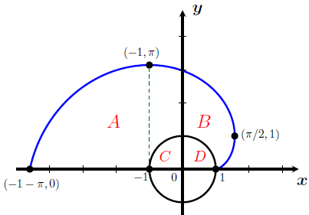 

The area of region ***C + D*** is:











The area of the region  is given by









|  |  |  |
| --- | --- | --- |
|  |  |  |
| **+** |  |  |
| **−** |  |  |

|  |  |  |
| --- | --- | --- |
|  |  |  |
| **+** |  |  |
| **−** |  |  |
| **+** | 1 |  |







Total area covered 



***Exercise***

An Air traffic controller spots two planes at the same altitude flying toward each other.

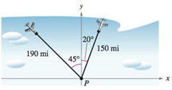

Their flight paths are 20° and 315°. One plane is 150 *miles* from point *P* with a speed of 375 *miles per hour*. The other is 190 *miles* from point *P* with a speed of 450 *miles per hour*.

1. Find parameteric equations for the path of each plane where *t* is the time in *hours*, with  corresponding to the time at which the air traffic controller spots the planes.
2. Use part (*a*) to write the distance between the planes as a function of *t*.
3. Graph the function in part (*b*).
4. When the distance between the planes be minimum?
5. If the planes must keep a separation of at least 3 *miles*, is the requirement met?

***Solution***

1. 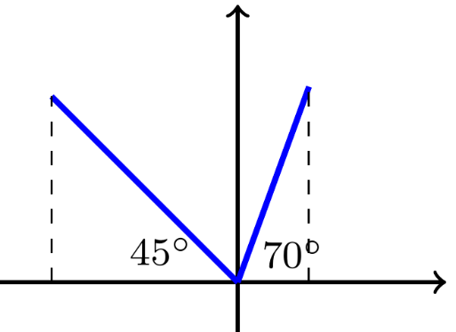***First*** Plane:

***Given***: 





***Second*** Plane:

***Given***: 







1. 



At 





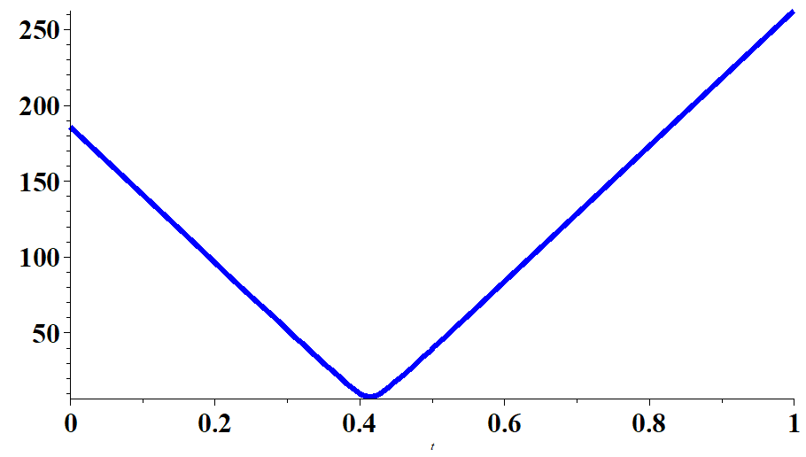

1. Using software:

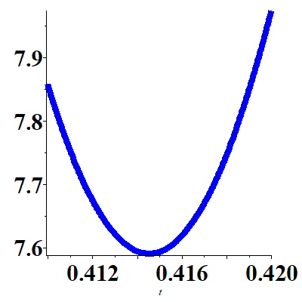

***t d***

0.4100000000 7.8578282443

0.4105000000 7.8029045315

0.4110000000 7.7540582513

0.4115000000 7.7114048932

0.4120000000 7.6750477077

0.4125000000 7.6450765223

0.4130000000 7.6215666744

0.4135000000 7.6045780909

0.4140000000 7.5941545371

**0.4145000000 7.5903230599**

0.4150000000 7.5930936382

0.4155000000 7.6024590542

0.4160000000 7.6183949864

0.4165000000 7.6408603242

0.4170000000 7.6697976925

0.4175000000 7.7051341728

0.4180000000 7.7467821981

0.4185000000 7.7946405981

0.4190000000 7.8485957667

0.4195000000 7.9085229209

0.4200000000 7.9742874225

The minimum distance is 7.59 ***miles*** when 

1. Yes, the planes must keep a separation of at least 3 *miles.*